**JOBSHEET 1**

**Programming Languages (Java Development Kit / JDK Installation)**

1. **Learning Outcome**

* Students must understand the concept of the program and the programming language
* Students must be able to install Java programming tools
* Students must understand the basic structure of Java
* Students must be able to compile and debug program

1. **Labs Activity**
   1. **Experiment 1: Installing the Java Development Kit / JDK**

**Experiment time: 120 minutes**

1. Download the JDK by opening the following URL <http://www.oracle.com/technetwork/java/javase/downloads/index.html>
2. Double click on the installation file that has been downloaded, then follow the installation process instructions.
3. The next step is setting PATH (specifically for Windows operating systems), so that **java** **commands** can be recognized by operating system environments.
4. The way to do PATH settings is by opening **Control Panel-> System-> Advanced System Settings-> Environment Variables**. Then look for the **PATH** variable, if it doesn't already exist then create the PATH variable.
5. The next step is, filling in the PATH variable, if the PATH variable already exists do not delete the existing value but add **C: \ Program Files \ Java \ jdk \ bin** (as a separator between values use character”;”).
6. The location of the JDK value is added according to the folder where Java is installed, in the example above the JDK is saved in C: \ Program Files.
7. Open the **Command Prompt** (Window + R, then type cmd), then type the **javac** command, if the command is recognized then the Windows operating system environment has known and has supported java programs, but if it has not been recognized do a check on the PATH setting (there may be an error when entering the directory location bin in the PATH variable).

**Question**

1. Why do we have to enter the **bin** folder location from Java into the **PATH** variable?
2. What is the use of **javac** command when entered at the command prompt!
   1. **Experiment 2 : Basic Structure of Java**

**Experiment time: 70 minutes**

**Text Editor Installation**

In order to write the source code, we will need to install a text editor application. There are so many text editor provided freely, such as notepad, IntelliJ, notepad++, atom, vscode etc. In this course we will use VSCode or IntelliJ as the text editor instead of any others. The following steps are VSCode installation procedures:

1. Download visual studio code from the URL <https://code.visualstudio.com/download>
2. Double click on the installer file that has been downloaded and follow the instructions.
3. After finishing the installation, open visual studio code and create a new file named **MyFirstJavaNoAbsen.java** (Use your own No Absen).

*change 00 with your own noAbsen

1. Write the following source code (this source code is the most basic structure of java program). Change 00 with your own noAbsen

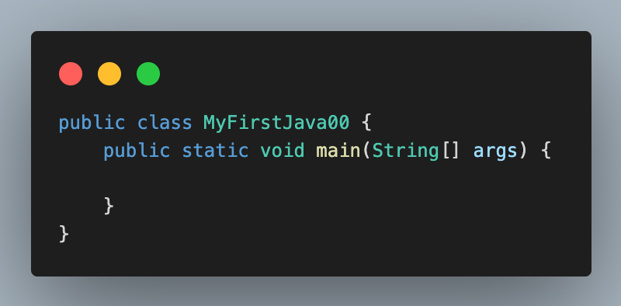

*Information:*

* *public is a keyword in Java that indicates that the objects, methods, or attributes can be accessed from other classes.*
* *class is a keyword in Java that is used to create a class*
* *static is a keyword to create a method that does not need to be instantiated first*
* *void is a keyword to make a method not return any values or are empty*
* *Name of the class and the file name should be equal*

1. Save the source code (File-> Save)
2. Open terminal in visual studio code

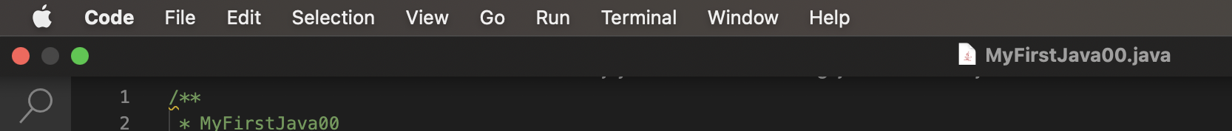

1. After the terminal panel has been opened, we have to open the directory or folder where we have created the source code file (**MyFirstJava00.java**) from the previous step. To change the directory, we can use **cd** command. For example if file **MyFirstJava00.java** is saved at “***F:\IFR\BAHAN-AJAR\DASPRO\2023-2024\#1 dasar algoritma dan bahasa pemrograman\src***”, then the command will be like this:

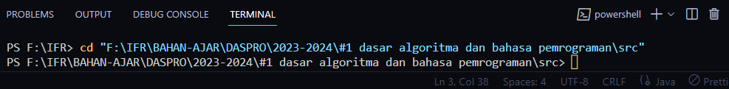

The directory where the source code is saved

1. After setting the terminal to be in the location of **MyFirstJava00.java**, then we can now compile the program by using **javac** command. It will be **javac NamaFile.java (javac MyFirstJava00.java)**

1. If the compilation has been done **successfully** then there will be **no error message**, **otherwise** you will get **the error message**. The error message will give us notification of what kind of error it is and where the error takes place. If the source code is compiled successfully, then the compiler will create a new file named **MyFirstJava00.class** in the same folder. The **.class** file contains the java byte code.

1. And finally we can run the program by using **java** command, **java NamaClass (java MyFirstJava00)**



1. After running the program, there is no output has been displayed on the terminal screen, because the source code that has been written is only the basic structure of the Java program. And there is no statement there, that is why the program will not have the output
2. Modifyfile **MyFirstJava00.java** by adding the following statement!

**Note : change xxxx with your name**

1. Save the change.
2. Re-compile the source code just like in step 8.
3. If there is no error, then continue to run the program like in step 9.
4. Observe the output of the program code! Is there any output in the terminal?

**Question!**

1. What is the use of **javac** command in the above steps? (**javac MyFirstJava00.java**)
2. What is the use of **java** command in the above experiment? (**java MyFirstJava00**)
3. What is the use of **main** method in java programming, what is the format of **main** method?
   1. **Experiment 3 : Adding the Extension for Java Code Pack in Visual Studio Code**

**Experiment time : 60 minutes**

1. Open Menu **Extension** then type “java” and you will get some extensions about java for Visual Studio Code. Choose **Extension Pack for Java** then install it.

1. Create a new file named **Latihan00.java** and don’t forget to change 00 with your name
2. Write the basic java structure, the extension pack will provide recommendations when creating classes. The following example by writing **c** will be given a class creation recommendation. When a recommendation appears, you can simply press the **tab** key. Likewise for the main function, when you type **main** and press **tab**. The main function will be created automatically.

1. Add the following statements!

1. Run the above code by pressing the **triangular** **run** **button** in the upper right corner.

1. Observe the output of the program! Is it the same as the following?



**Question!**

1. Change the statement **System.out.println** to be **System.out.print** at line 7 and 8, then run the program!
2. What is the difference between **System.out.println("..........");** and **System.out.print("............");?**
3. Change the statement at line 8 as the following syntax!

System.out.print("\nsaya adalah Mahasiswa Jurusan Teknologi Informasi - POLINEMA");

1. What is the use of **\n** at line 8!
2. Still at line 8, add character **//** in front of the source code!

//System.out.print("\nsaya adalah Mahasiswa Prodi Teknik Informatika");

1. Run the program and observe the result! And what is the use of character **//** ?
2. **Assignment**

**Times : 30 minutes**

Create a Java program with the following output, then explain the program you have created!

